Amazon SQS Configuration:

## **Queue Type**

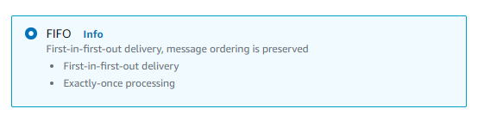

**Queue Type** is FIFO that will serve on the basis of first in first out delivery for respective consumers.

# **Configuration**

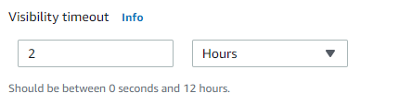

**Visibility timeout** sets the length of time that a message received from a queue (by one consumer) will not be visible to the other message consumers. For optimal performance, set the visibility timeout to be larger than the AWS SDK read timeout. This applies to using the ReceiveMessage API action with either short polling or long polling.

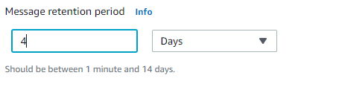

**The Message Retention Period** is the amount of time that Amazon SQS retains a message that does not get deleted. Amazon SQS automatically deletes messages that have been in a queue for more than the maximum message retention period. The default retention period is 4 days. The retention period has a range of 60 seconds to 1,209,600 seconds (14 days).

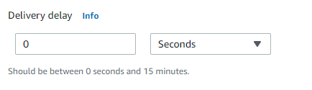

**Delivery delay**: If your consumers need additional time to process messages, you can delay each new message coming to the queue. The delivery delay is the amount of time to delay the first delivery of each message added to the queue. Any messages that you send to the queue remain invisible to consumers for the duration of the delay period. The default (minimum) delay for a queue is 0 seconds. The maximum is 15 minutes.

For FIFO queues, the per-queue delay setting is retroactive; changing the setting affects the delay of messages already in the queue.

## **Access Policy**

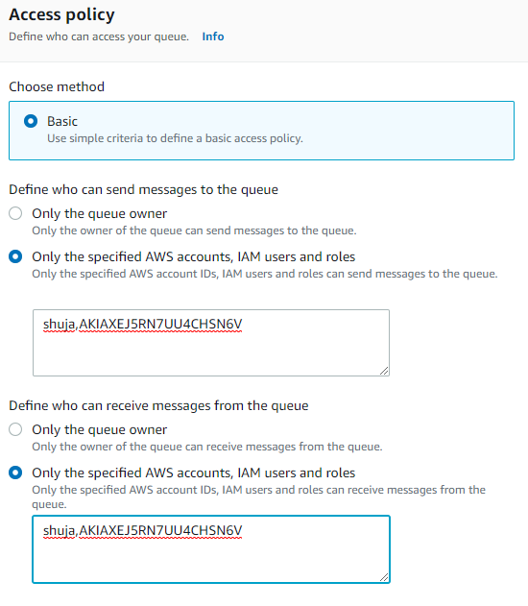

The Access policy is set by explicitly defining the IAM users or account IDs. It’s done intentionally so that only the mentioned accounts can access the queue through admin console as well through code.